EXP.NO: 3 | Write a Servlet program that prints "Hello, World!" when accessed through a browser.
DATE:20/02/2025

AIM:
To write a basic Servlet program that demonstrates the use of Java Servlets by printing "Hello, World!" when accessed through a browser.

ALGORITHM:

Input:
  - The user makes an HTTP request (usually by entering a URL) through a browser.

Servlet Program Flow:
- Create a Servlet Class:
  - Define a Java class that extends the HttpServlet class.
  - Override the doGet() method, which handles HTTP GET requests from the client (browser).

Handle HTTP Request:
  - In the doGet() method:
    - Get the PrintWriter object to write the response to the browser.
    - Set the response content type to text/html.
    - Write the "Hello, World!" message to the response.

Compile the Servlet Class:
  - Compile the Java Servlet file using the javac command to generate a .class file.

Deploy the Servlet:

  - Place the compiled servlet class file in the appropriate directory of the web application (typically in the /WEB-INF/classes folder).
  - Configure the servlet in the web.xml file of the web application or use annotations.

Access the Servlet via Browser:
  - Start the Apache Tomcat or another servlet container.
  - Access the servlet by entering the appropriate URL (e.g., http://localhost:8080/your-webapp/hello).

CODE:

Form.html:
<!-- index.html -->
<!DOCTYPE html>
<html lang="en">
<head>
<meta charset="UTF-8">
<meta name="viewport" content="width=device-width, initial-scale=1.0">
<title>Student Information Management System</title>

<style>
body{
margin:0;
font-family:Arial, sans-serif;
background:linear-gradient(135deg,#1565c0,#42a5f5,#00c6ff);
}

.container{
width:450px;
margin:60px auto;
background:white;
padding:30px;
border-radius:15px;
box-shadow:0 10px 25px rgba(0,0,0,0.2);
}

h2{
text-align:center;
color:#1565c0;
margin-bottom:25px;
}

input, select, textarea{
width:100%;
padding:12px;
margin:10px 0;
border:1px solid #ccc;
border-radius:8px;
font-size:15px;
box-sizing:border-box;
}

textarea{
resize:none;
height:90px;
}

button{
width:100%;
padding:12px;
background:#1565c0;
color:white;
border:none;
border-radius:8px;
font-size:16px;
cursor:pointer;
}

button:hover{
background:#0d47a1;
}
</style>
</head>

<body>

<div class="container">
<h2>Student Details Submission</h2>

<form action="StudentServlet" method="post">

<input type="text" name="name" placeholder="Student Name" required>

<input type="number" name="age" placeholder="Age" required>

<select name="dept" required>
<option value="">Select Department</option>
<option>CSE</option>
<option>ECE</option>
<option>IT</option>
<option>MECH</option>
<option>CIVIL</option>
</select>

<input type="text" name="roll" placeholder="Roll Number" required>

<textarea name="address" placeholder="Address"></textarea>

<button type="submit">Submit</button>

</form>
</div>

</body>
</html>

Javascript:

// StudentServlet.java

import java.io.*;
import javax.servlet.*;
import javax.servlet.http.*;
import javax.servlet.annotation.WebServlet;

@WebServlet("/StudentServlet")

public class StudentServlet extends HttpServlet {

protected void doPost(HttpServletRequest request,
HttpServletResponse response)
throws ServletException, IOException {

response.setContentType("text/html");

PrintWriter out = response.getWriter();

String name = request.getParameter("name");
String age = request.getParameter("age");
String dept = request.getParameter("dept");
String roll = request.getParameter("roll");
String address = request.getParameter("address");

out.println("<html><body style='font-family:Arial;background:#f4f7fc;'>");

out.println("<div style='width:500px;margin:50px auto;background:white;padding:25px;border-radius:15px;box-shadow:0 0 15px gray;'>");

out.println("<h2 style='color:#1565c0;text-align:center;'>Student Information Submitted Successfully</h2>");

out.println("<p><b>Name:</b> " + name + "</p>");
out.println("<p><b>Age:</b> " + age + "</p>");
out.println("<p><b>Department:</b> " + dept + "</p>");
out.println("<p><b>Roll Number:</b> " + roll + "</p>");
out.println("<p><b>Address:</b> " + address + "</p>");

out.println("</div>");
out.println("</body></html>");
}
}

Output:

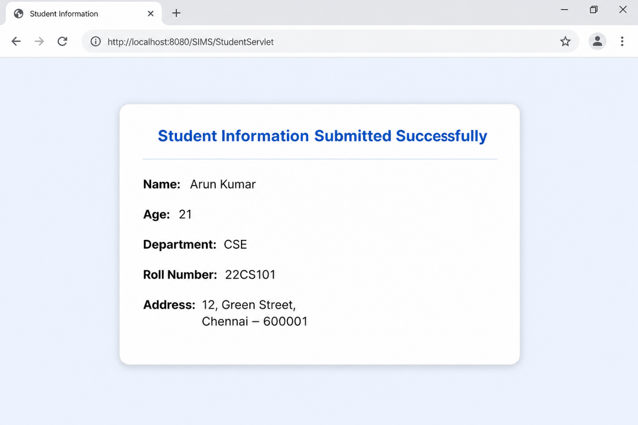

RESULT:
The browser will display the message "Hello, World!" returned by the Servlet.

